|  |
| --- |
| Staffordshire Games Institute |

GAMES DEVELOPMENT PROJECT

PROPOSAL

**Name: Cassette Costen**

**Enrolled Course: Computer Games Programming**

**Student Number: 23025180**

***Comparison of Voxel Meshing Techniques using Marching Tetrahedra***

Contents

What Problem are you trying to solve? 3

Areas for Research, Investigation and Methodology: 4

What are the deliverables? 5

Planning Documentation 5

Sample of work you have completed to this date (relevant to project): 6

# What Problem are you trying to solve?

*Generation of meshes based on non-mesh data (for instance, a scalar field generated by a noise function) is known as* ***isosurface extraction.*** *This is typically done using the well-known* ***marching cubes*** *algorithm; however, this approach produces uneven triangles and surfaces which are difficult to shade smoothly. This project intends to explore the use of* ***marching tetrahedra*** *and* ***vertex clustering*** *to improve the visual quality and rendering efficiency of meshes generated.*

*The project will aim to balance speed of generation with visual quality of the result, to allow realtime mesh generation. The artefact will test different methods of performing isosurface extraction and vertex clustering, as well as different voxel resolutions, and the effects these changes have on computational performance and visual fidelity.*

How does this Project help your employability?

*The principles involved with the project are core to* ***graphics programming*** *and* ***technical art****. Further, the technique of isosurface extraction is commonly used in terrain generation and other meshing applications, which often are considered a field of expertise in themselves.*

*The 'Technical Artist’ role advertised by Pixel Toys (*[*https://www.linkedin.com/jobs/view/4297527612/*](https://www.linkedin.com/jobs/view/4297527612/)*) mentions that a key part of the job is researching new technologies to improve the studios games and game production workflows. This project could provide a useful tool for realtime terrain generation, and the skillset developed by the project – developing graphics-focussed solutions; digesting mathematical papers for insight into a problem area and its solutions – is ideal for a role focused around maintaining and improving graphical/art tools and workflows.*

# Areas for Research, Investigation and Methodology:

## 

*The two main areas for investigation are tetrahedral isosurface extraction, and mesh post-processing techniques (specifically vertex clustering).*

*This will include literature research to develop an understanding of variations on tetrahedral meshing, and how they might be implemented. I am aware of two key variations in how tetrahedra are arranged: simple cubic, and body-centered diamond cubic; I plan to conduct primary research on whether these two different techniques produce visually distinct and/or more performant results, both of which can be quantified (the first with user testing, the second with collection of timing data for sample scenarios).*

*A preliminary literature search shows that there are various techniques for vertex clustering, and my literature research will involve isolation of 2-3 performant techniques, ideally which promote consistent triangle area. My primary research will then involve comparing the effect these different post-processing techniques have on mesh generation performance using timing data for sample scenarios.*

*I also intend to study the relationship between perceived visual quality (via user testing), computational performance (via timing data for sample scenarios), and voxel resolution, as the basis for analysis on diminishing returns for terrain resolution.*

*This testing will be carried out close to the end of the artefact development period of the project.*

# **What are the deliverables?**

*The deliverable will be a standalone C# library containing functionality to generate triangle meshes from a sample function (provided by the user), with the ability to control the voxel resolution and specific techniques used for mesh generation.*

# **Planning Documentation**

*Below is an outline of the key tasks involved with the development of the project, using a Kanban board. Time management will be tracked using timing software to compare to estimates. Time estimates and the task list will be updated to reflect the ongoing development (i.e. when new challenges appear).*

*The tasks are tagged according to the kind of work involved (literature research versus artefact development), and the development tasks function as key milestones for the artefact.*

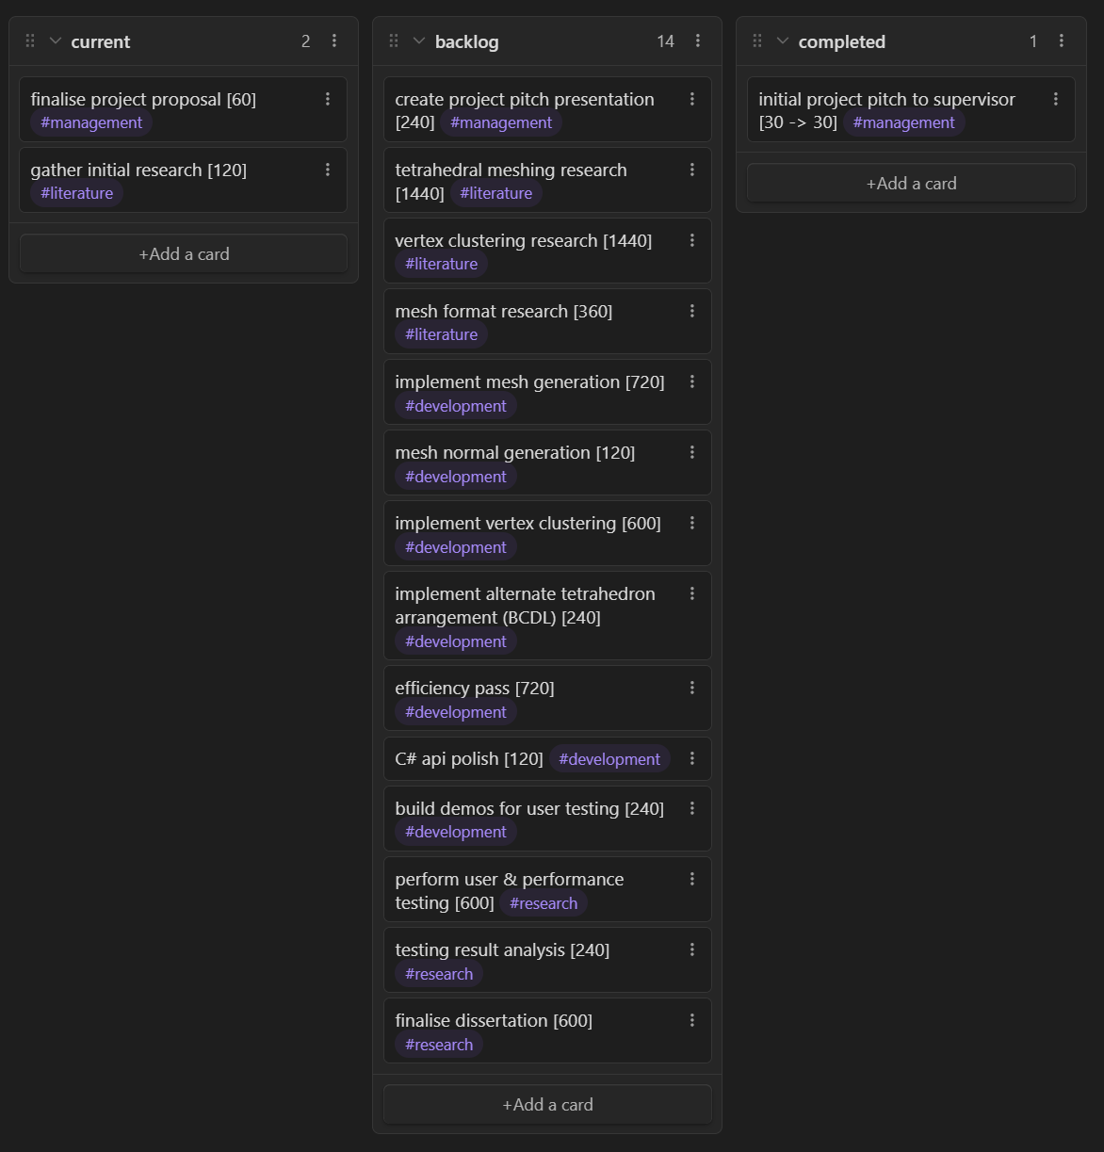

*The development of the artefact will be performed under version control software (git) which allows tracking of changes and provably dating individual milestones.*

# Sample of work you have completed to this date (relevant to project):

*I developed an experimental test of this technology in this repository:* [*https://github.com/oculometric/rainvault*](https://github.com/oculometric/rainvault)*, which gives me an insight into both the nature of the algorithms being studied, and the tasks involved with implementing them.*

*I have a strong familiarity with graphics programming and the performance considerations necessary for the project. I have previously developed a rendering engine using the low level Vulkan API in this repository:* [*https://github.com/oculometric/planetarium*](https://github.com/oculometric/planetarium)*, which has given me a strong understanding of how geometry is handled and represented.*

*In this:* [*https://github.com/oculometric/origami-sunset*](https://github.com/oculometric/origami-sunset) *project I developed a simple CPU-based rendering algorithm, which gives me a good foundation in mathematical and algorithmic optimisation.*